My CMIL MURP experience was super enlightening as I was able to learn a lot about the different kinds of research that you can do, different educational pathways, and most importantly different career pathways that are attainable with my degree.

For the course of my CMIL MURP internship, my mentor was the future Dr. Devon Kelley, for her project she was looking into the burrowing crabs; abiotic conditions are physiologically ideal in coastal marshes and their behavior with each other. From this I was able to experience what days in the field looked like. Once a month we went to 3 different marshes across San Diego and used traps to catch crabs, take samples of the water quality, and on the following day from setting out the traps, go back and measure the crabs we caught before releasing them back into the wild.

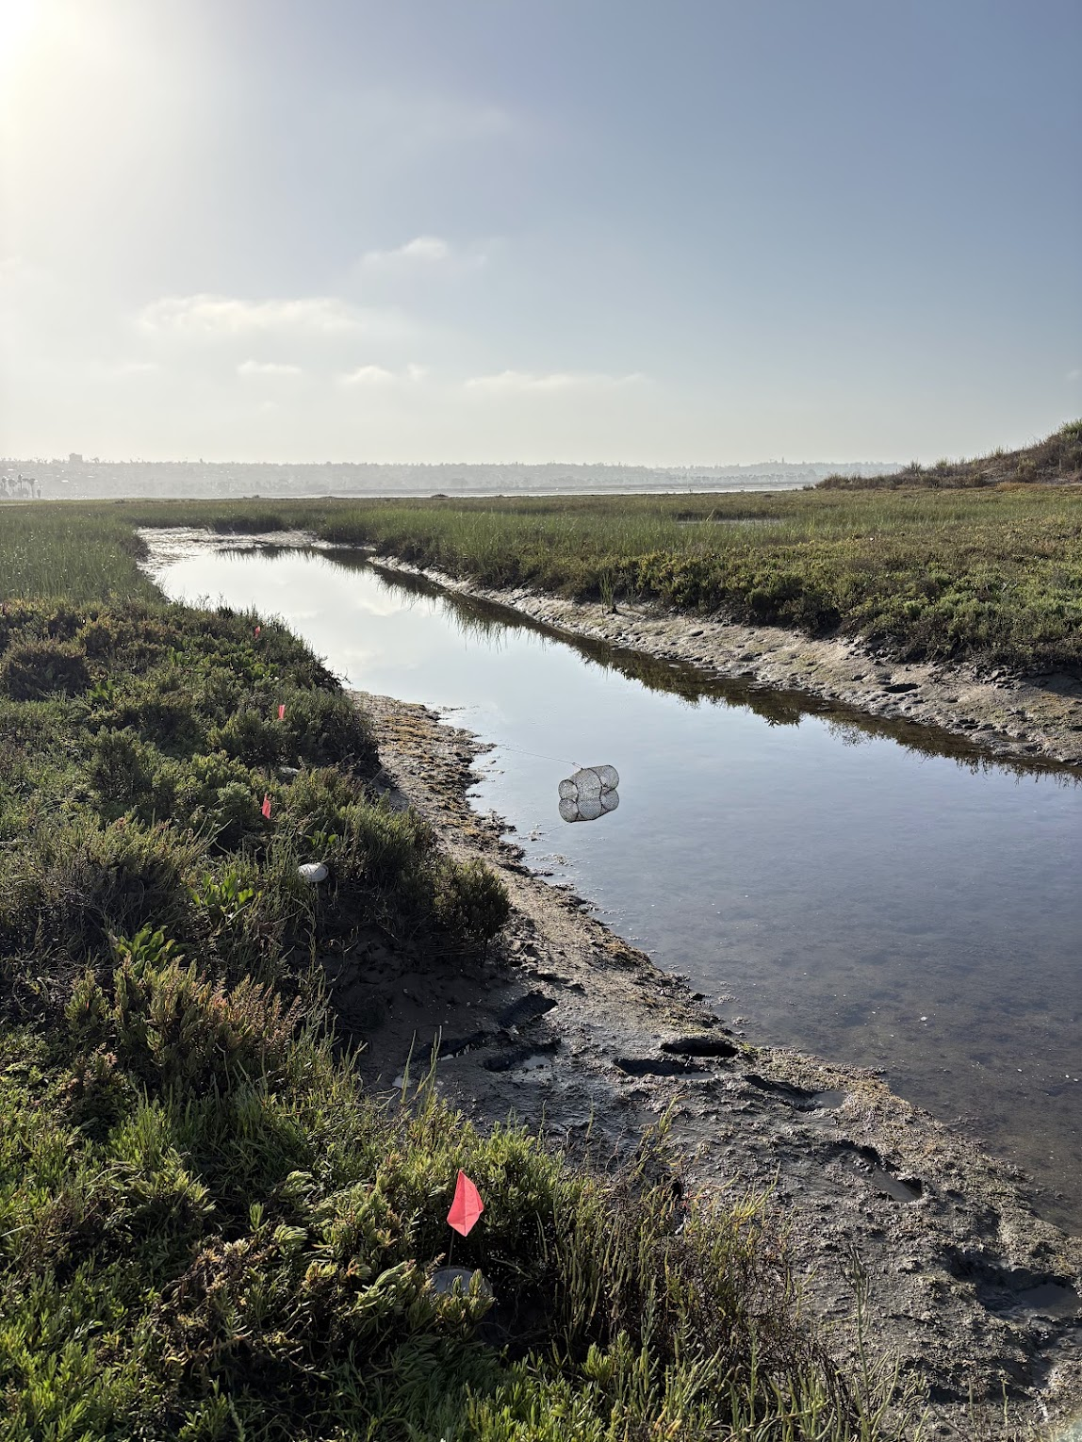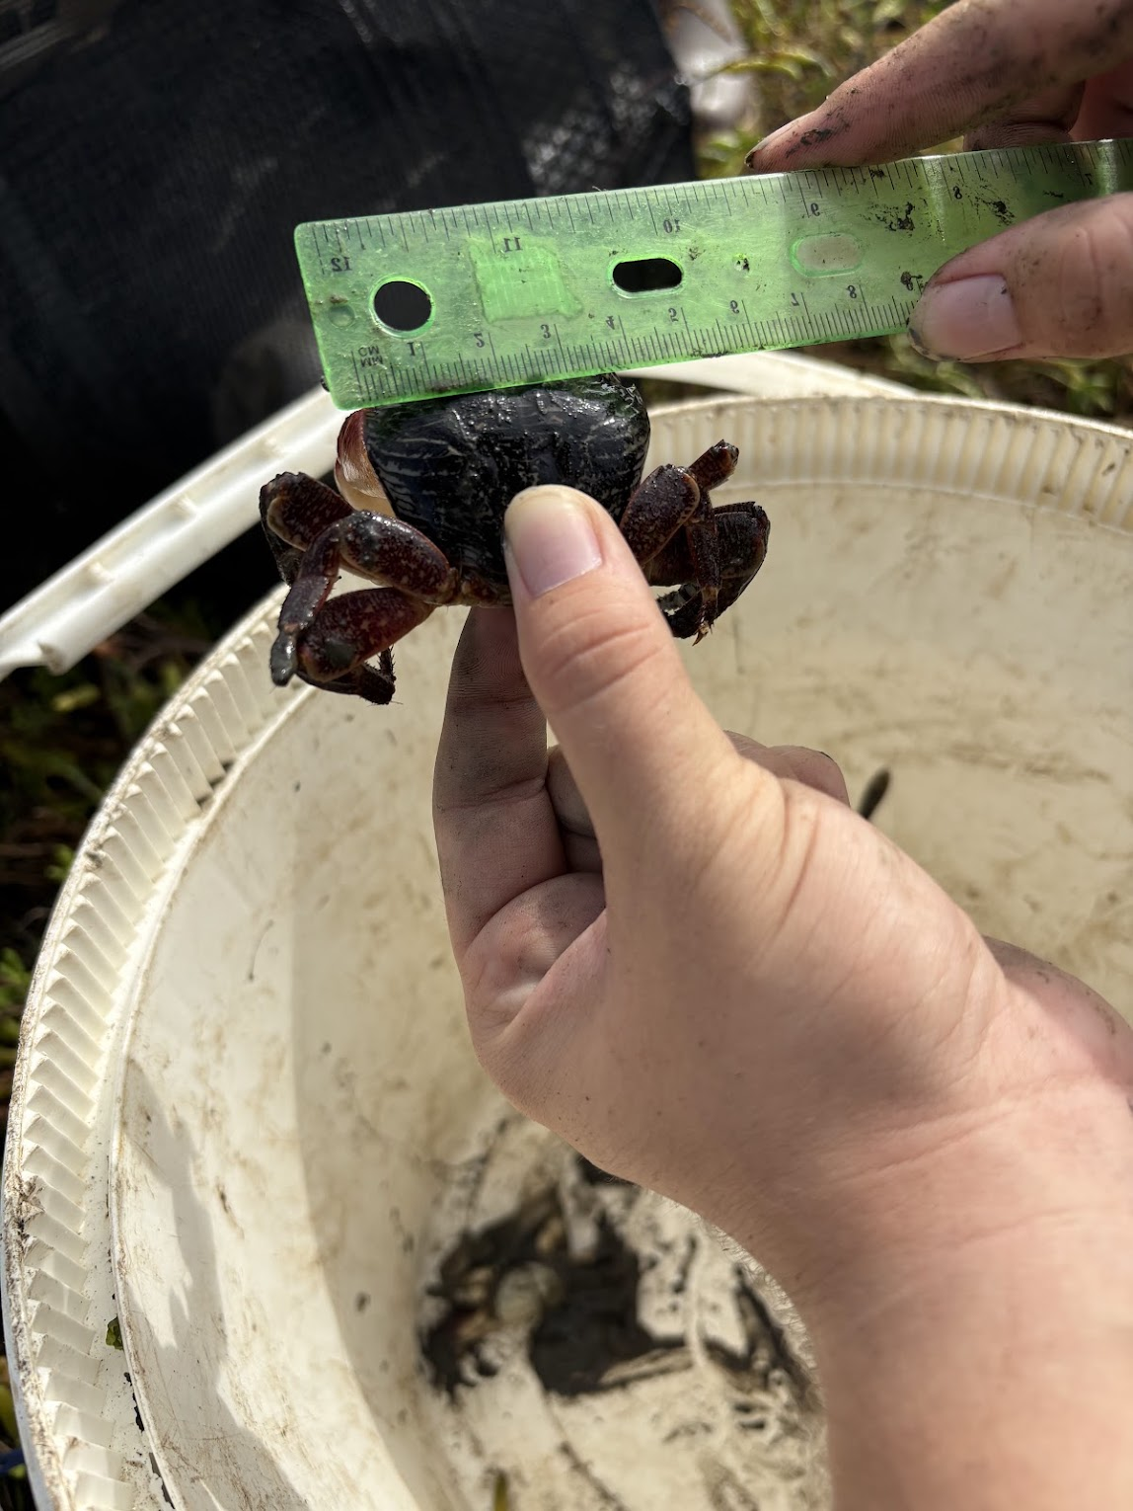

For me, this was super interesting as it allowed me to experience field work for the first time. As previous to this I had only done lab work within my class at SDSU. These classes like biology 203 and 204 were tailored to multiple classes of kids, so there were a lot more preserved and dried specimens for my classes, especially 204. Being able to go collect and touch real crabs showed me how different it could all be. I also learned to pick up crabs, and how cute and funny they can be, as I in the past have not been a fan of touching or picking up crabs, especially with how maneuverable their claws can be.

These mornings in the marshes were extra special, as I would never have been able to do this without someone doing research. As they are all protected and blocked from the public. So being able to go where others cannot allow a really cool look into the wildlife there. I was able to see multiple endangered rails in the marshes, which was really special. Along with more crabs then I think anyone could ever count.

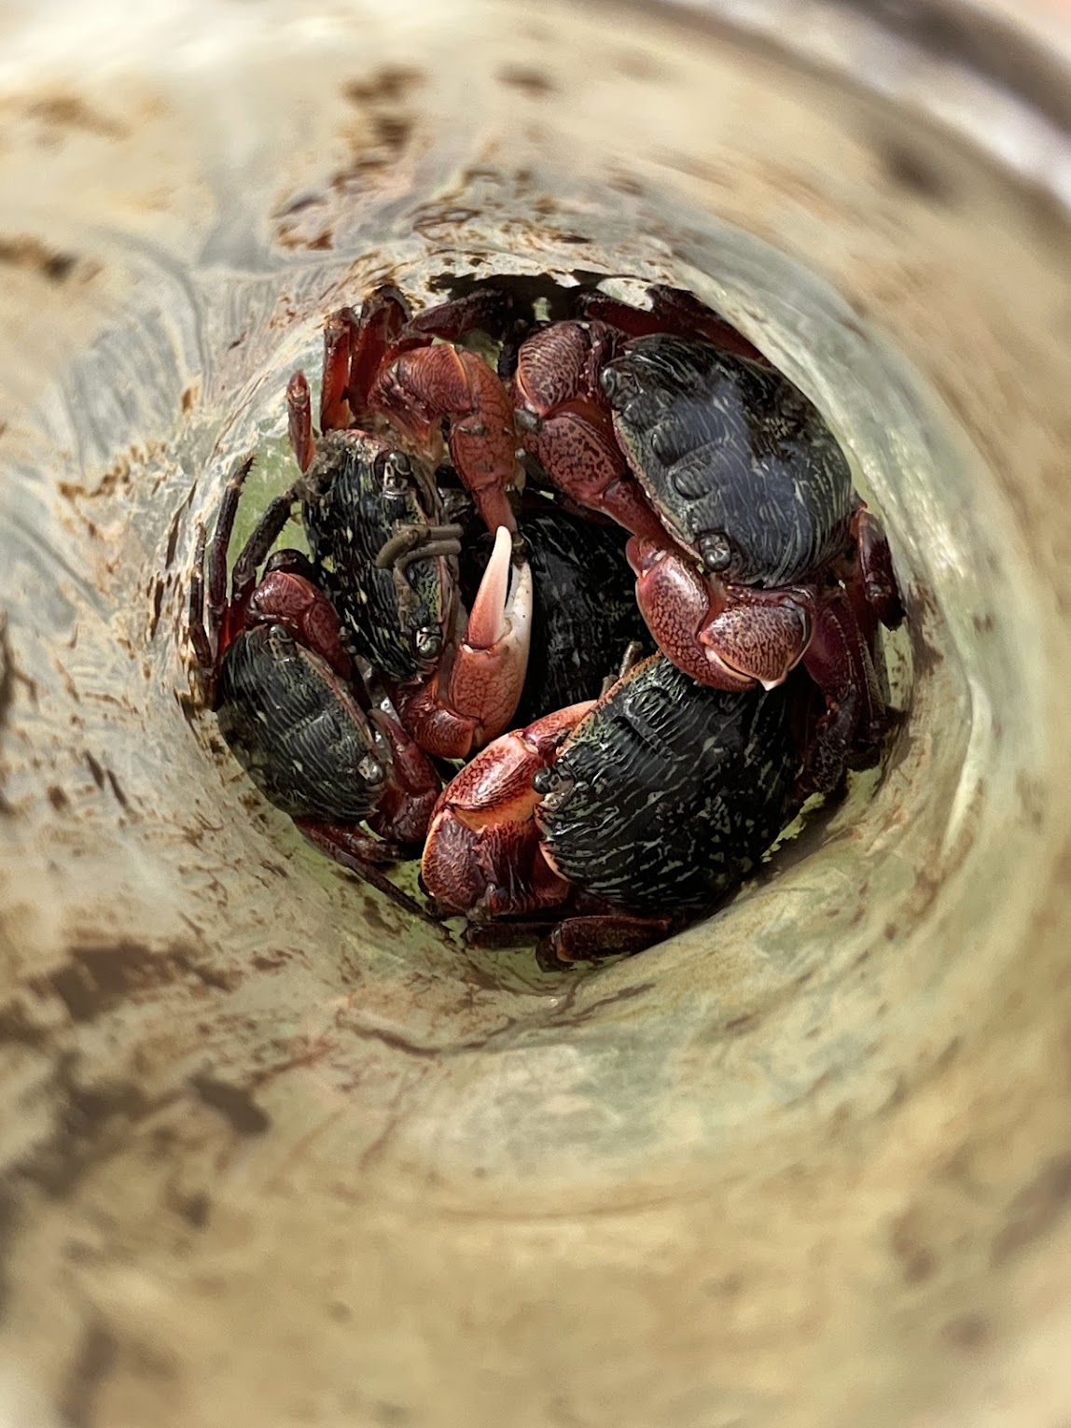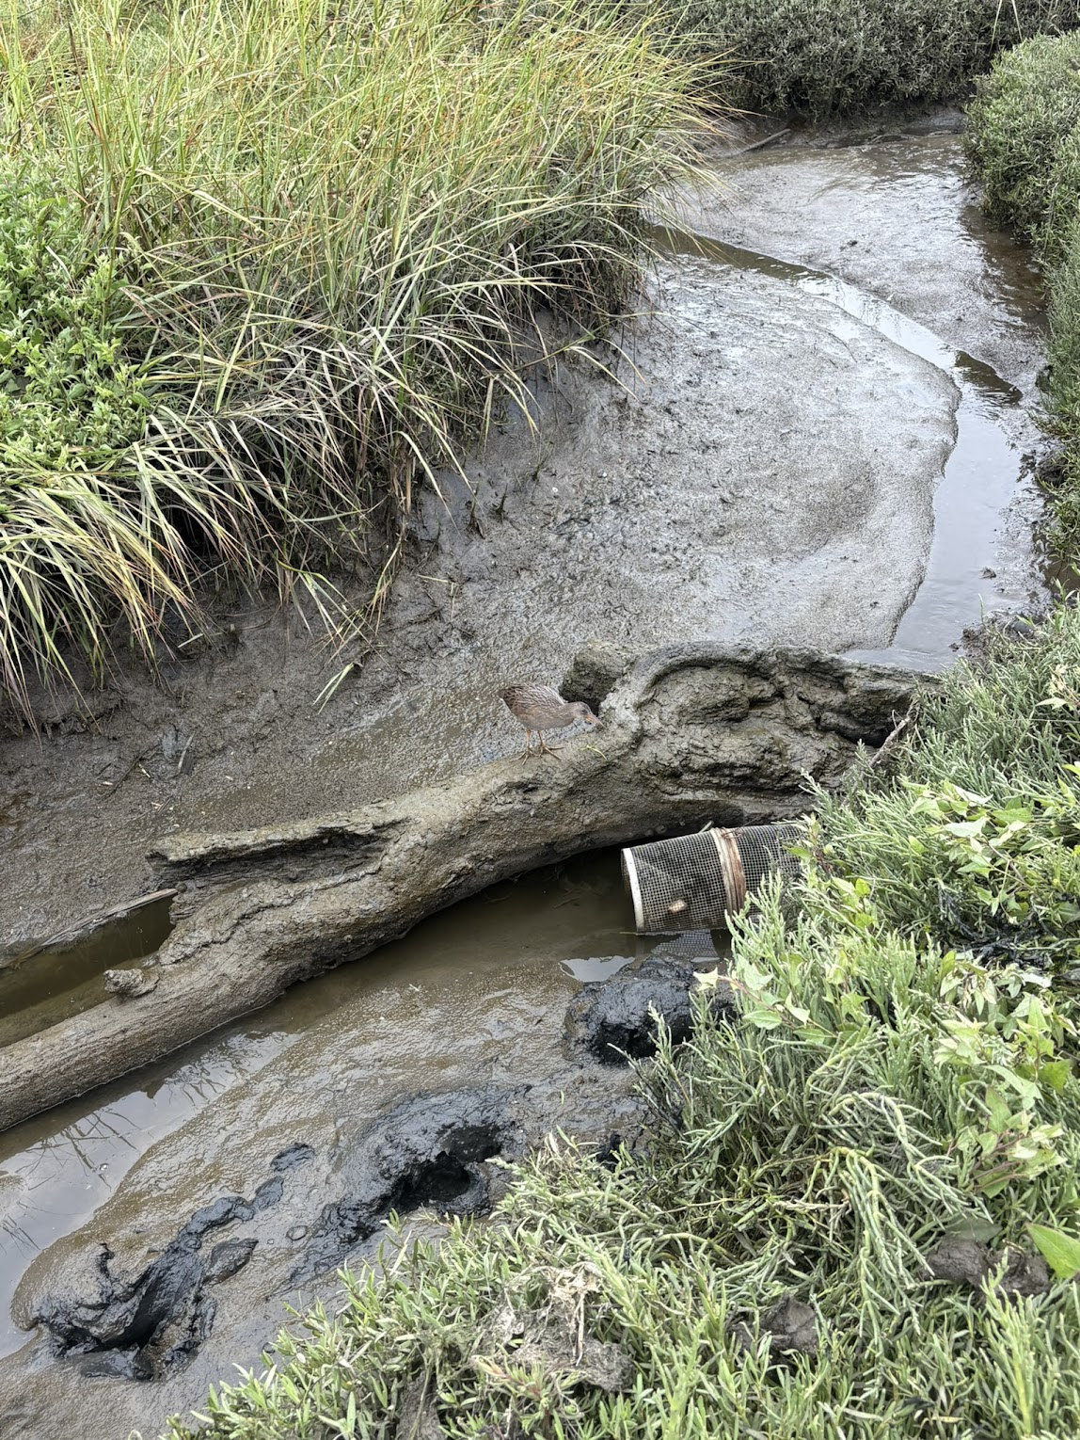

This experience taught me a lot. My original plan was to go to graduate school post graduation with my bachelors. But I hadn’t thought about what that would look like beyond wanting to get a masters or doctorate. With this internship I went to a panel about the different graduate school options and programs. Was able to learn what the application process would actually entail. And most importantly learn about the different programs in the area like the Davis and SDSU joint program. As well as the differences of work/school level between masters and doctors programs

All in all this was a wonderful experience, and I am so happy that I was able to be an intern and part of the program. It has taught me so much about what I want, and how to attain these goals.

